|  |  |
| --- | --- |
| Project Name: | HRAS |
| Test Case Number: | 3.5-1 |
| Brief description: | Demonstrate the Change Room button on the Patient page |
| Relevant section of spec doc: | 3.5 |

Input Assumptions:

Relevant state of DB.

Other relevant environmental assumptions (if any): (system config, etc.) This function is available to both regular users and admins, so we will be using the “Bypass Login” temporary feature.

User Actions:

1. From the Login Page, click the “Bypass Login” button to reach the Main Page
2. From the Main Page, click the “Search Patient” button to reach the Search Patient Page.
3. In their respective search fields, type the First Name “Rachael” and the Last Name “Barnett”.
4. Click on the top result in the result box to select the patient, and then click the “Submit” button to reach the patient page for Rachael Barnett.
5. On this Patient Page, click the “Change Room” button to reach the Change Room form.

Expected Results:

Upon clicking the “Change Room” button, the Change Room form should appear overlapping the Patient page.

Actual Result:

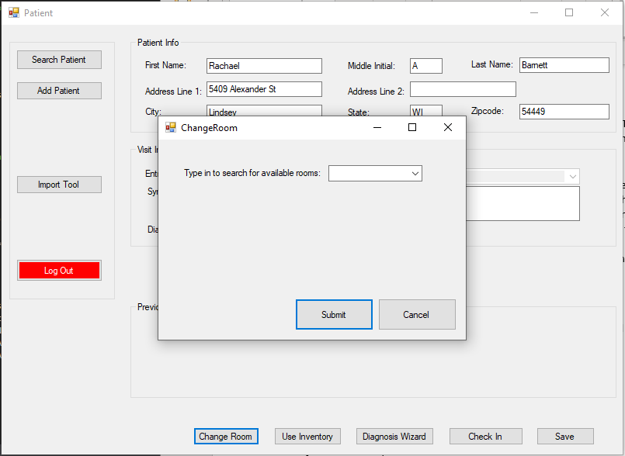

The Change Room form appeared overlapping the Patient page

Result matches expected result? Yes  No

If not then, fill out the information below:

|  |  |
| --- | --- |
| Defect Report Number: |  |
| Assigned to: |  |